Operator Overloading
Need - user defined objects can also behave like built-in data types, improves code readability

- 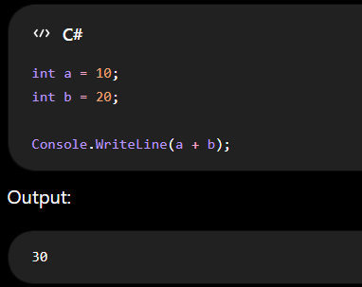

- 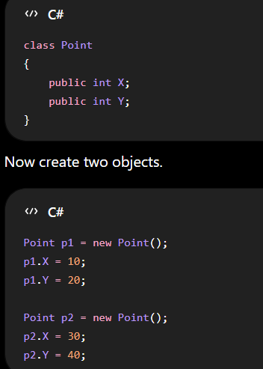

- Output of Point p3 = p1 + p2;
- -> (40,60) or (300,800)
- It gives Error
  - 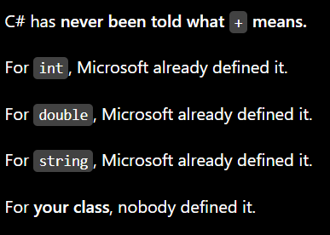

To solve this, C# introduce Operator Overloading
- Explicitly telling C# what an operator should do
- Syntax
  - 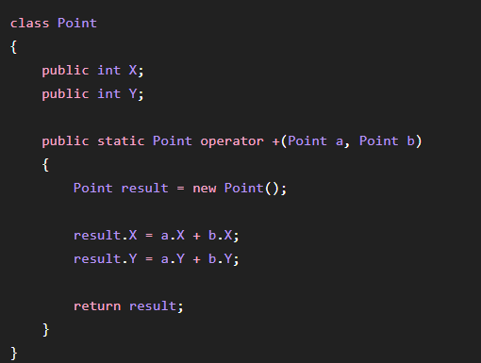
  - Method is static as operator belongs to entire class, not to an individual object.
  - Internally -
    - Point p3 = Point.operator +(p1, p2);

- All the Arithmetic, Relational , Unary, Bitwise, Conversion (implicit , explicit) operators can be overloaded
- Implicit Operator Conversion
  - Use this when conversion is always safe
    - 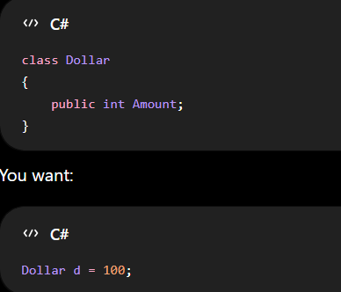
      - Not Allowed
  - 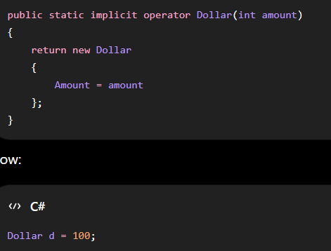
    - Allowed

- Explicit Operator Conversion
  - 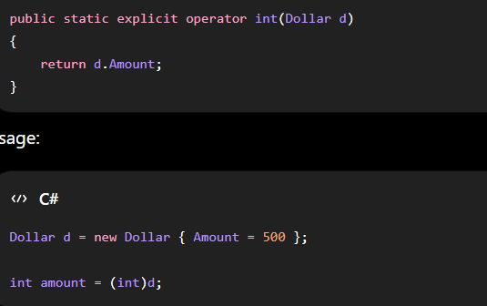

Rules for operator overloading
- Must be public static.
- At least one operand must be the containing type.
  - Eg- public static Point operator +(Point a, int b)
  - Not -- public static Point operator +(int a, int b)
- Operators that can't be overloaded
=
.
?:
is
as
new
typeof
sizeof
nameof
??=

